Englefield CE Primary School
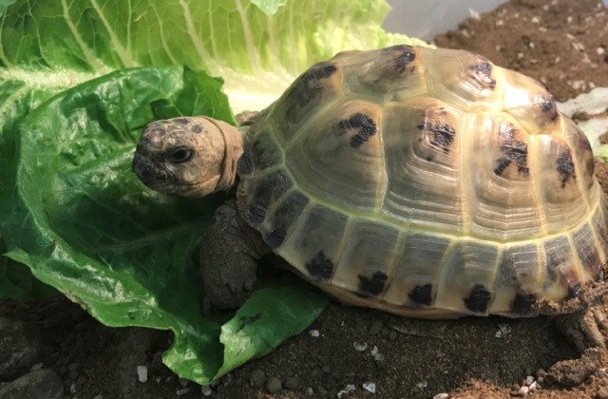
Our new school year has started with a really positive feel around school. New classes have bonded and old friends have taken great delight in seeing each other after such a long break. We also welcomed back Pebbles, our school tortoise, who has been staying with various school families over the summer.
Our new pupils have been real stars. They are a confident bunch and have settled really quickly into life at Englefield; I think we can expect great things from them over the coming years.
As many of you are aware, we lost a number of pupils last year because of families relocating which has changed the feel of some of our classes. For a small school like ours, losing pupils during their primary years, for whatever reason, creates a bit of a void in their cohort. With only 16 children in each year, firm friendships are made which will last a lifetime but to benefit fully from these, pupils really need to be able to remain here until Year 6. Please remember that if you know someone in the area with older children who were hoping to bring their children to our school and be part of our happy, family community, please make sure they know that we may be able to accommodate them.
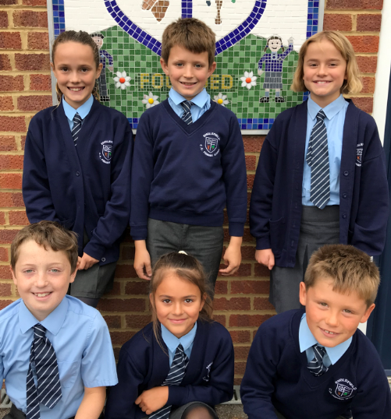
This year we have a worship group made up of 6 pupils from Years 5 and 6. They attended a worship workshop and have already started putting some new ideas into practice: objects for class prayer tables which can aid reflection, a new prayer table in the school hall, pupil-led whole-school assemblies, new responses to be said during our collective worship and matching purple cloths for our prayer tables. Hopefully these actions will help our pupils and staff to think even more deeply about our school’s Christian values and how we can live them day to day.

Like last year, a small group of Year 5 and 6 pupils are spending some time at Rushall Farm. The activities they are doing are designed to build confidence, resilience, teamwork and leadership skills, all of which should have an impact on their progress back in the classroom. Sandra Stone who leads our group is a real star and makes every session enjoyable, fun and informative…thank you to Rushall Farm for providing this wonderful resource.
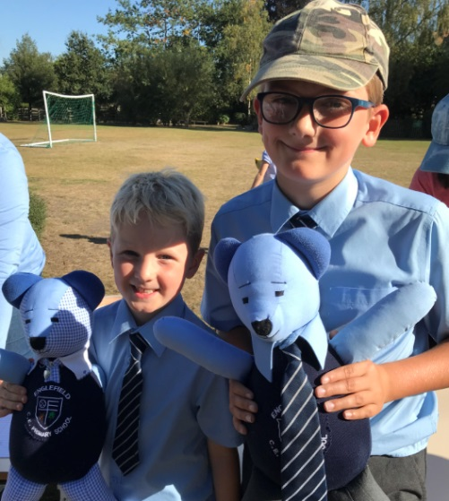
Finally the PTA welcomed back all our families with a party after school. There was a lovely atmosphere and it gave our new families a chance to get to know us better. We also introduced our two new bears who were donated to the school by the Paterson family; they are made out of Englefield school uniform. We are holding a draw to see who can find their names…watch this sapce!
Please remember that you are always welcome to contact the school (930 2337) if you would like to come in for a visit or to help in any way.

